**L1:**

**L1(C3, C2, C1, EN, CLK, S1, S2, S3, S4) = C3'C2'ENS1 + C3'C2ENS2 + C3C2'C1'ENS3 + C3C2C1ENS1 + C3C2'C1ENCLK'S2 + C3C2'C1ENS1'S2 + C3C2'C1ENS2S3' + C2'ENS1S2S3S4**

**Minterms:**

40,41,42,43,44,45,46,47,56,57,58,59,60,61,62,63,104,105,105,106,107,108,109,110,111,120,121,122,123,124,125,126,127,164,165,166,167,172,173,174,175,180,181,182,183,188,189,190,191,228,229,230,231,236,237,238,239,244,245,246,247,252,253,254,255,290,291,294,295,298,299,302,303,306,307,310,311,314,315,318,319,356,357,358,359,364,365,366,367,372,373,374,375,380,381,383,383,488,489,490,491,492,493,494,495,504,505,506,507,508,509,510,511

Table :K-map for L1

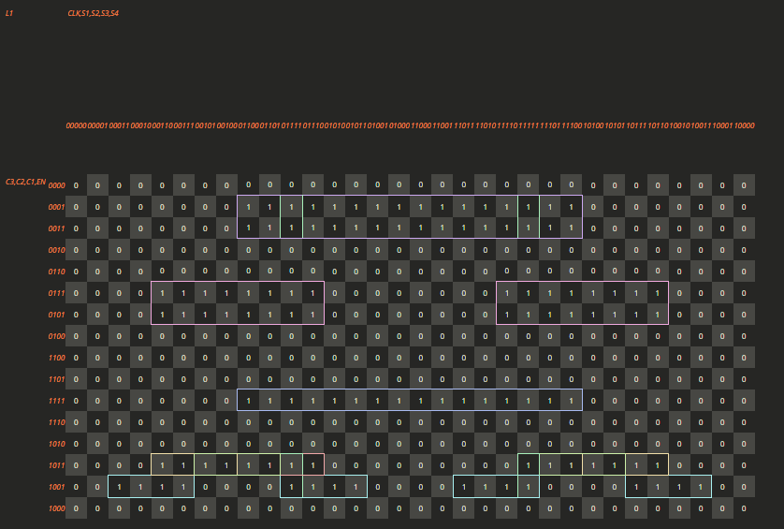

**L2:**

**L2(C3, C2, C1, EN, CLK, S1, S2, S3, S4) = C3'C2'ENS2 + C3'C2ENS4 + C3C2'C1'ENS1 + C3C2C1ENS2**

**Minterms:**

36, 37, 38, 39, 44, 45, 46, 47, 52, 53, 54, 55, 60, 61, 62, 63, 100, 101, 102, 103, 108, 109, 110, 111, 116,117, 118, 119, 124, 125, 126, 127, 161, 163, 165, 167, 169, 171, 173, 175, 177, 179, 181, 183, 185, 187, 189, 191, 225, 227, 229, 231, 233, 235, 237, 239, 241, 243, 245, 247, 249, 251, 253, 255, 296, 297, 298, 299, 300, 301, 302, 303, 312, 313, 314, 315, 316, 317, 318, 319, 484, 485, 486, 487, 492, 493, 494, 495, 500, 501, 502, 503, 508, 509, 510, 511

Table :K-map for L2

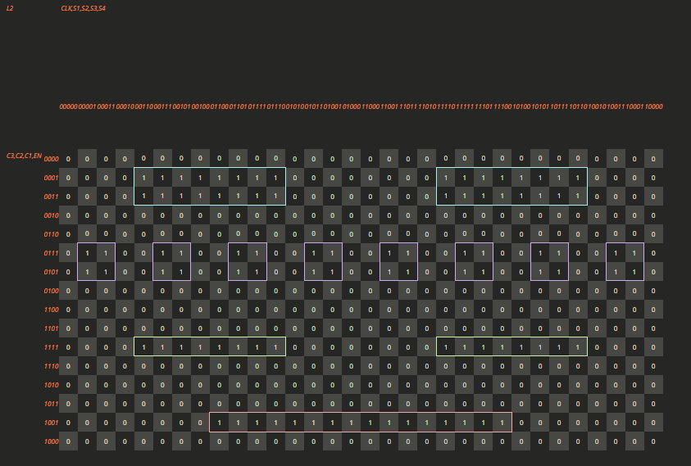

**L3:**

**L3(C3, C2, C1, EN, CLK, S1, S2, S3, S4) =** C3'C2'ENS3 + C3'C2C1'ENS1 + C1ENS3 + C3C2'C1'ENS2

**Minterms:** 34,35,38,39,42,43,46,47,50,51,54,55,58,59,62,63,98,99,102,103,106,107,110,111,114,115,118,119,122,123,126,127,168,169,170,171,172,173,174,175,184,185,186,187,188,189,190,191,226,227,230,231,234,235,238,239,242,243,246,247,250,251,254,255,292,293,294,295,300,301,302,303,308,309,310,311,316,317,318,319,354,355,358,359,362,363,366,367,370,371,374,375,378,379,382,383,482,483,486,487,490,491,494,495,498,499,502,503,506,507,510,511

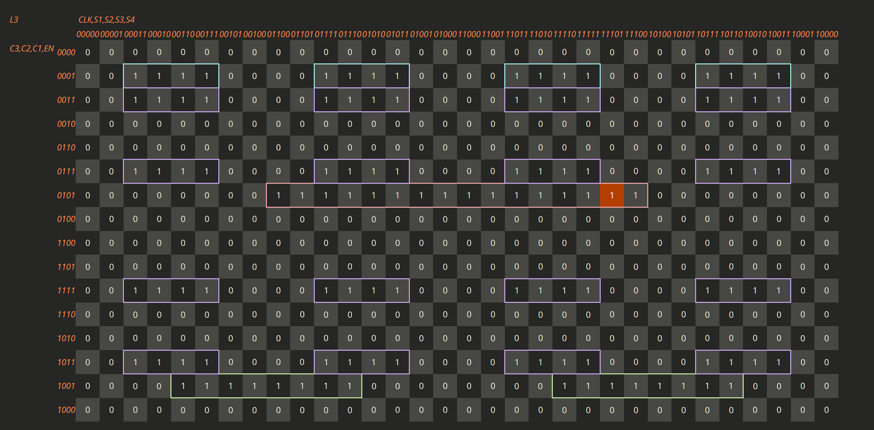

Figure :Kmap for L3

**L4:**

**Minterms:**

33,35,37,39,41,43,45,47,49,51,53,55,57,59,61,63,97,99,101,103,105,107,109,111,113,115,117,119,121,123,125,127,162,163,166,167,170,171,174,175,178,179,182,183,186,187,190,191,232,233,234,235,236,237,238,239,248,249,250,251,252,253,254,255,289,291,293,295,297,299,301,303,305,307,309,311,313,315,317,319,360,361,362,363,364,365,366,367,376,377,378,379,380,381,382,383,481,483,485,487,489,491,493,495,497,499,501,503,505,507,509,511

**L4(C3, C2, C1, EN, CLK, S1, S2, S3, S4) =** C3'C2'ENS4 + C3'C2C1'ENS3 + C3'C2C1ENS1 + C2'C1'ENS4 + C3C2'C1ENS1 + C3C2C1ENS4

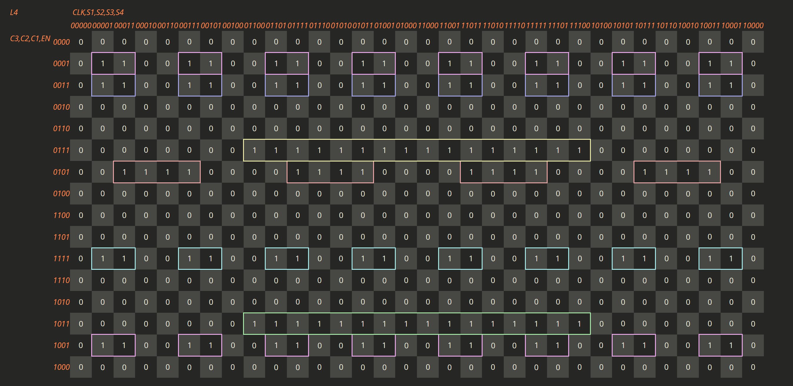

**N1:**

**N1(C3, C2, C1, EN, CLK, S1, S2, S3, S4) = C3'C2'C1'ENS1'S2S3'S4' + C2'ENCLK'S1'S2S3'S4' + C1ENCLKS1'S2'S3'S4 + C3'C2ENCLKS1'S2'S3'S4 + C2C1ENCLKS3S4' + C2C1ENCLKS2S4' + C2C1ENCLKS1S4' + C3C2'ENCLK' + C3C2'ENS1'S2'S3' + C3C2'ENS4 + C3C2'C1'ENS2S3 + C3C2'C1'ENS1S3 + C3C2'C1'ENS1S2 + C3C2C1EN**

**Minterms:**

36, 52, 100, 113, 177, 241, 242, 244, 246, 248, 250, 252, 254, 288, 289, 290, 291, 292, 293, 294, 295, 296, 297, 298, 299, 300, 301, 302, 303, 304, 305 , 307, 309, 310, 311, 313, 314, 315, 316, 317, 318, 319, 352, 353, 354, 355, 356, 357, 358, 359, 360, 361, 362, 363, 364, 365, 366, 367, 368, 369, 371, 373, 375, 377, 379, 381, 383, 480, 481, 482, 483, 484, 485, 486, 487, 488, 489, 490, 491, 492, 493, 494, 495, 496, 497, 498, 499,  
500, 501, 502, 503, 504, 505, 506, 507, 508, 509, 510, 511

Table :K-map of N1

**N2:**

**N2(C3, C2, C1, EN, CLK, S1, S2, S3, S4) = C2'C1ENCLKS1'S2'S3S4' + C3'C2ENCLK' + C3'C2ENS1S4 + C3'C2C1'ENS3 + C3'C2C1'ENS2 + C3C2'ENCLKS1'S2'S3S4' + C2'ENCLKS1'S2S3'S4' + C3C1ENCLKS1S4' + C3C2C1EN + C3'C2'ENS1'S2S3'S4' + C3'C2ENS1'S2'S3'S4' + C3'C2ENS3S4 + C3'C2ENS2S4 + C3C1ENCLKS3S4'**

**Minterms:**

36, 52, 100, 114, 116, 160, 161, 162, 163, 164, 165, 166, 167, 168, 169, 170, 171, 172, 173, 174, 175, 176, 178, 179, 180, 181, 182, 183, 185, 186, 187, 188, 189, 190, 191, 224, 225, 226, 227, 228, 229, 230, 231, 232, 233, 234, 235, 236, 237, 238, 239, 240, 243, 245, 247, 249, 251, 253, 255, 306, 308, 370, 372, 374, 376, 378, 380, 382, 480, 481, 482, 483, 484, 485, 486, 487, 488, 489, 490, 491, 492, 493, 494, 495, 496, 497, 498, 499, 500, 501, 502, 503, 504, 505, 506, 507, 508, 509, 510, 511

Table :K-map of N2

**Kmap for N3:**

Minterms: 32, 33, 34, 35, 36, 37, 38, 39, 40, 41, 42, 43, 44, 45, 46, 47, 48, 49, 50, 51, 52, 53, 54, 55, 56, 57, 58, 59, 60, 61, 62, 63, 96, 97, 98, 99, 100, 101, 102, 103, 104, 105, 106, 107, 108, 109, 110, 111, 112, 114, 115, 117, 118, 119, 120, 121, 122, 123, 124, 125, 126, 127,178, 184, 224, 225, 226, 227, 228, 229, 230, 231, 232, 233, 234, 235, 236, 237, 238, 239, 240, 242, 243, 244, 245, 246, 247, 248, 249, 250, 251, 252, 253, 254, 255, 306, 312, 352, 353, 354, 355, 356, 357, 358, 359, 360, 361, 362, 363, 364, 365, 366, 367, 368, 369, 370, 371, 372, 373, 374, 375, 376, 377, 378, 379, 380, 381, 382, 383, 480, 481, 482, 483, 484, 485, 486, 487, 488, 489, 490, 491, 492, 493, 494, 495, 496, 497, 498, 499, 500, 501, 502, 503, 504, 505, 506, 507, 508, 509, 510, 511

**N3(C3, C2, C1, EN, CLK, S1, S2, S3, S4) =** C3'C2'C1'EN + C3'ENCLKS1'S2'S3S4' + C3'ENCLKS1S2'S3'S4' + C1ENCLK' + C1ENS3 + C1ENS1 + C2'ENCLKS1'S2'S3S4' + C2'ENCLKS1S2'S3'S4' + C3C1EN + C3'C2'ENS2'S4' + C1ENS2S4 + C2C1ENS4'

